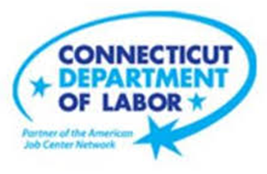

**NEW WEEKLY JOB POSTINGS FROM   
HELP WANTED ONLINE  
Office of Research**

**Week Ending November 19th, 2022: Connecticut Down 2% Over The Week, U.S. Down 4%.**WETHERSFIELD, November 29th, 2022 – During the week ending November 19th, there were 7,773 new postings, down 161 new ads or -2% over the week. Eleven industries declined and nine increased. Educational Services had the largest decline, down 550 new ads. The over the week decline in this industry was the result of new ad drops in many school districts in the state, the largest being New Haven Public Schools (-120 new ads), Bridgeport Public Schools (-80 new ads), and Stamford Public Schools (-80 new ads). Among the nine increasing industries, Retail Trade had the largest over-the-week increase, up 197 new ads. The largest retail trade employer increases occurred at Gap Inc. (+39 new ads) and TJX (+36 new ads). Health Care & Social Assistance was up 171 new ads over the week, the largest gains occurred at Community Health Center, Inc. (+156 new ads). The graph below illustrates weekly total change for Connecticut and the United States. During the week ending November 19th, Connecticut’s 2% drop was half the 4% drop experienced by the United States overall.  
  
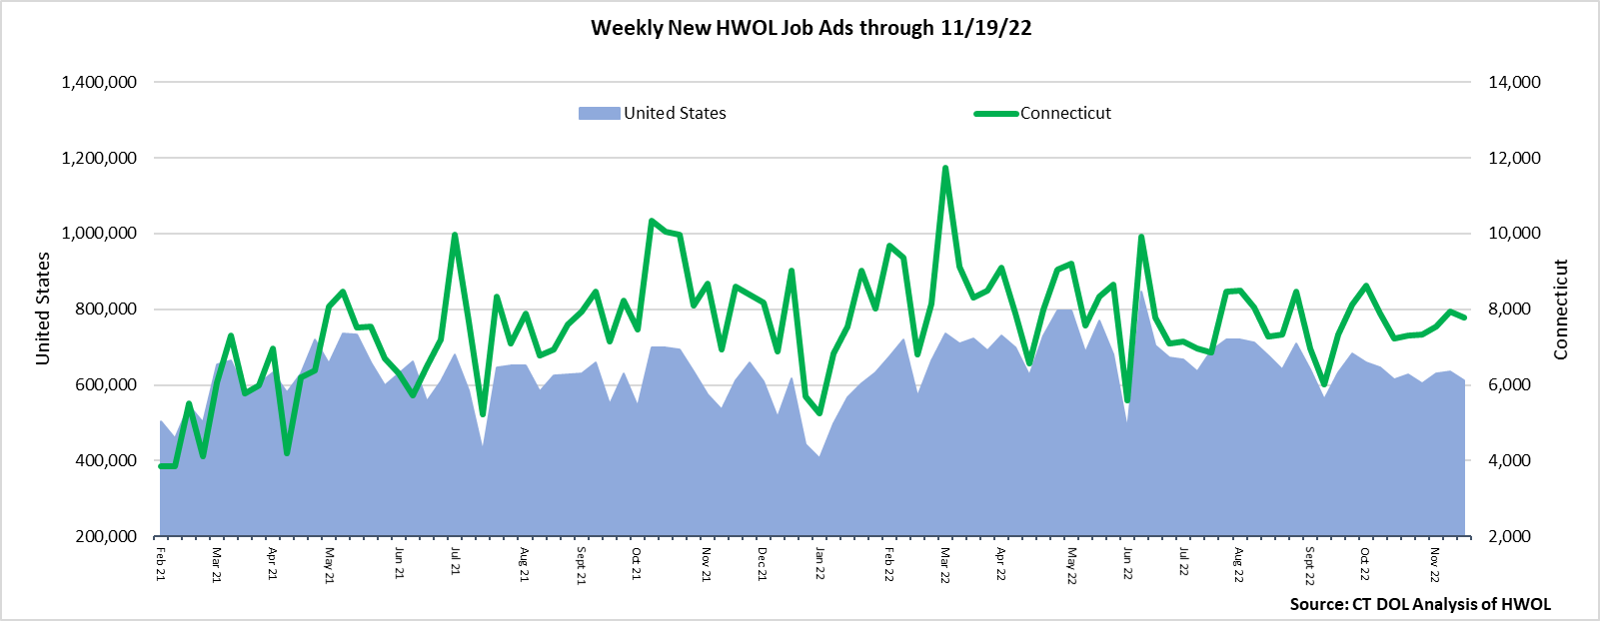  
**Industries** with the most new postings include Health Care & Social Assistance, Retail Trade, and Manufacturing.

**Occupations** with the most new postings include Registered Nurses, Retail Salespersons, and Supervisors of Retail Sales Workers.

**Employers** with the most new postings include Community Health Center Inc., United Parcel Service, and Hartford Healthcare.

**The three industries with the most new job postings were:**

* **Health Care & Social Assistance** (1,619 new postings, +12% over the week)
* **Retail Trade** (778 new postings, +34% over the week)
* **Manufacturing** (740 new postings, +12% over the week)

   
 During the week ending November 19th, 2022, the 2% new ad total decrease is the net result of declines in 9 industries, increases in 11 industries, and one unchanged industry. The 9 decreasing industries fell by a combined 744 new ads and two-thirds of that combined drop occurred in Educational Services (-550 new ads). The increasing industries grew by a combined 583 new ads with most of that occurring in Retail Trade (+197 new ads). Over four weeks, new ads were up 7% or +486 new ads. 13 industries were up and 8 were down. Large four-week increases occurred in Educational Services (+255 new ads) and Health Care & Social Assistance (+199 new ads). The largest four-week industry declines occurred in Professional, Scientific, & Technical Services (-130 new ads) and Finance & Insurance (-70 new ads).

For more information on total job ads by industry for Connecticut and its labor market areas, see the monthly report available here: <https://www1.ctdol.state.ct.us/lmi/hwol.asp>

**New Job Postings by Occupation** 

**The occupations with the most new postings were:**

* Registered Nurses (388 new postings, +9% over the week)
* Retail Salespersons (260 new postings, +11% over the week)
* Sales Representatives, Wholesale & Manufacturing (185 new postings, +65% over the week)

**Employers with the Most New Job Postings**  Employers with the most new job postings during the week were mostly in Healthcare & Social Assistance, Finance & Insurance, and Retail Trade. The 25 employers shown above account for 18 percent of all new ads. 19 of 25 employers in the top 25 increased over the week and 6 decreased. The top 25 employers with the largest over the week increase and decrease respectively were Community Health Center, Inc. (+156 new ads) and Yale-New Haven Health System (-75 new ads).   
  
**What is HWOL?**The **Conference Board Help Wanted Online**® Data Series (HWOL) measures the number of new, first-time Online job postings and jobs reposted from the previous month for over 16,000 Internet job boards, corporate boards, and smaller job sites that serve niche markets and smaller geographic areas. To view more HWOL data, go to: <https://www1.ctdol.state.ct.us/lmi/hwol.asp>